Chapter 10 – Files and Exceptions

Purpose of Working with Files
- Makes programs more practical and user-friendly.
- Allows programs to:
  - Analyze large amounts of data.
  - Save user data between runs.
  - Resume where users left off.
- Prevents crashes through proper error handling.
- Improves program stability and robustness.

Reading from a File

Opening a File

An incredible amount of data is available in text files. Text files can contain weather data, traffic data, socioeconomic data, literary works, and more. Reading from a file is particularly useful in data analysis applications, but it’s also applicable to any situation in which you want to analyze or modify information stored in a file.

For example, you can write a program that reads in the contents of a text file and rewrites the file with
formatting that allows a browser to display it.

When you want to work with the information in a text file, the first step is to read the file into memory. You can read the entire contents of a file, or you can work through the file one line at a time.

with open('filename.txt') as file_object:
- open() opens the file.
- Returns a file object.
- with automatically closes the file.
- Avoids problems caused by forgetting close().

Reading Entire File: read() method

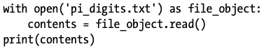

- open() function takes one argument, file name (you want to open)
then returns an object representing the file and assigns it (in this case, file_object)
which we will work with later
- The key word with closes the file once access to it is no longer needed. Notice how we call open() but not close(). If a bug in your program prevents the close() method from being executed, the file may never close.
* This may seem trivial, but improperly closed files can cause data to be lost or corrupted.
* If you call close() too early in your program, you will find yourself trying to work with a closed
file (a file you cant access).
* It’s not always easy to know exactly when you should close a file, but with the structure shown
here, Python will figure that out for you. All you have to do is open the file and work with it as
desired, trusting that Python will close it automatically when the with block finishes execution.
- read() reads the entire content of the file and stores it as one long string in the value (in this case, contents).
When we print the value of contents, we get the entire text file back:
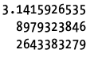
NOTE:
Python does not create a new variable scope for with blocks.
Only these create new scope:
- Functions
- Classes
- Modules

So contents still exists after the block.
The only difference between this output and the original file is there is an extra blank line at the end of the program. The blank line appears because read() returns an empty string when it reaches the end of the file; this empty string shows up as a blank line.
If you want to remove the extra blank line, you can use rstrip() in the print statement:
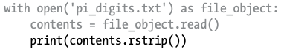
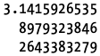
File Paths

IMPORANT NOTE:
When you open a file, make sure you are on the same folder as the file WITHIN the terminal. If not, it will state Python cant find file in the current working directory.

Relative Path: Based on current program location.
Because text_files is inside python_work, you could use a relative file path to open a file from text_files. A relative file path tells Python to look for a given location relative to the directory where the currently running program file is stored. For example, you’d write:

This line tells Python to look for the desired .txt file in the folder text_files and assumes that text_files is located inside python_work (which it is).

Absolute Path: Full path from system root.

You can also tell Python exactly where the file is on your computer regardless of where the program that’s being executed is stored. This is called an absolute file path. You use an absolute path if a relative path doesn’t work. For instance, if you’ve put text_files in some folder other than python_work say, a folder called other_files—then just passing open() the path 'text_files/filename.txt' won’t work because Python will only look for that location inside python_work. You’ll need to write out a full path to clarify where you want Python to look.

Absolute paths are usually longer than relative paths, so it’s helpful to assign them to a variable and then pass that variable to open():

Important Notes
- Windows uses \ but forward slashes / work in Python.
- Backslashes must be escaped:
- "C:\\path\\to\\file.txt"

Reading Line by Line
When you’re reading a file, you’ll often want to examine each line of the file. You might be looking for certain information in the file, or you might want to modify the text in the file in some way. For example, you might want to read through a file of weather data and work with any line that includes the word sunny in the description of that day’s weather. In a news report, you might look for any line with the tag <headline> and rewrite that line with a specific kind of formatting.

You can use a for loop on the file object to examine each line from a file one at a time:

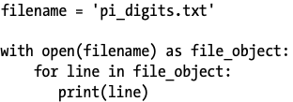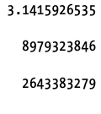

- First we assign the name of the file with the variable filename
- Call open(), an object representing the file and its contents is assigned to the variable file_object
- Use the with syntax to let Python open and close the file properly
- To examine the file’s contents, we work through each line in the file by looping over the file object.

These blank lines appear because an invisible newline character is at the end of each line in the text file. The print function adds its own new line each time we call it, so we end up with two newline characters at the end of each line: one from the file and one from print(). Using rstrip() on each line in the print() call eliminates these extra blank lines:
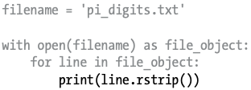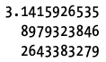

Reading into a List: readlines() method
When working the the with syntax, the file object returned by open() is only available inside the with block that contains it. If you want to retain access to a file’s contents outside the with block, you can store the file’s lines in a list inside the block and then work with that list.

The readlines() method takes each line from the file and stores it in a list. This list is then assigned to lines, which we can continue to work with after the with block ends. We use then use a for loop to print each line from lines. Because each item in lines corresponds to each line in the file, the output matches the contents of the file exactly.

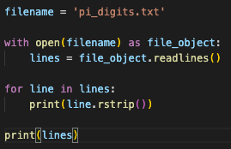

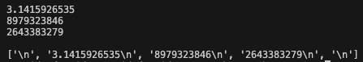

Working with File Contents

Building a String
After you’ve read a file into memory, you can do whatever you want with that data, so let’s briefly explore the digits of pi. First, we’ll attempt to build a single string containing all the digits in the file with no whitespace in it:

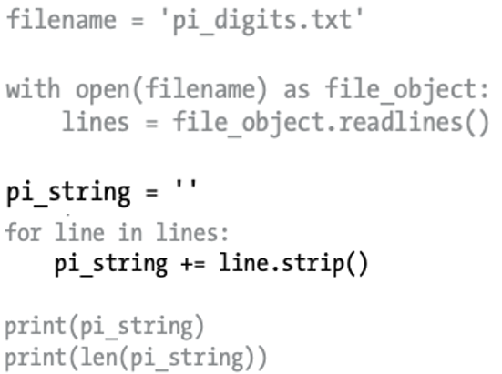

Converting Data Types
When Python reads from a text file, it interprets all text in the file as a string. If you read in a number and want to work with that value in a numerical context, you’ll have to convert it to an integer using the int() function or convert it to a float using the float() function.

Large Files
- Same logic works for very large files.
- Python can handle as much data as memory allows.

So far we’ve focused on analyzing a text file that contains only three lines, but the code in these examples would work just as well on much larger files. If we start with a text file that contains pi to 1,000,000 decimal places instead of just 30, we can create a single string containing all these digits. We don’t need to change our program at all except to pass it a different file. We’ll also print just the first 50 decimal places, so we don’t have to watch a million digits scroll by in the terminal:

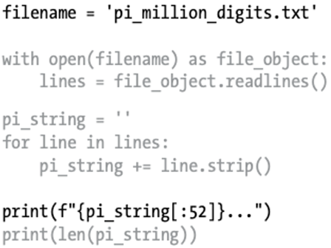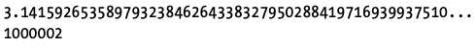

Check if birthday is in pi
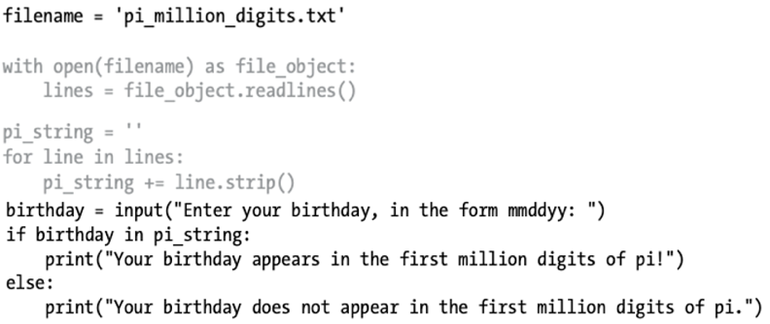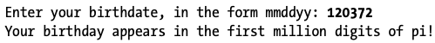

Writing to Files
One of the simplest ways to save data is to write it to a file. When you write text to a file, the output will still be available after you close the terminal containing your program’s output. You can examine output after a program finishes running, and you can share the output files with others as well. You can also write programs that read the text back into memory and work with it again later.

Writing to an Empty File

To write text to a file, you need to call open() with a second argument telling Python that you want to write to the file. To see how this works, let’s write a simple message and store it in a file instead of printing it to the screen:

The call to open() in this example has two arguments. The first argument is still the name of the file we want to open. The second argument, 'w', tells Python that we want to open the file in write mode. You can open a file in read mode ('r'), write mode ('w'), append mode ('a'), or a mode that allows you to read and write to the file ('r+'). If you omit the mode argument, Python opens the file in read-only mode by default.

The open() function automatically creates the file you’re writing to if it doesn’t already exist. However, be careful opening a file in write mode ('w') because if the file does exist, Python will erase the contents of the file before returning the file object.

We use the write() method on the file object to write a string to the file. This program has no terminal output, but if you open the file programming.txt, you’ll see one line:

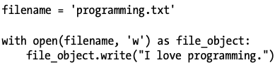

Modes
- 'r' → read (default)
- 'w' → write (overwrites file)
- 'a' → append
- 'r+' → read and write
⚠ Opening in 'w' erases existing content.
Writing Multiple Lines

The write() function doesn’t add any newlines to the text you write. So if you write more than one line without including newline characters, your file may not look the way you want it to:

If you open programming.txt, you’ll see the two lines squished together:

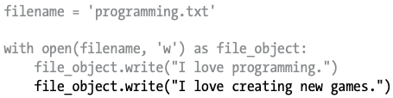
Including newlines in your calls to write() makes each string appear on its own line.
The output now appears on separate lines:

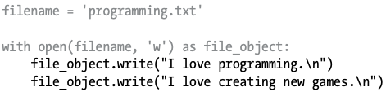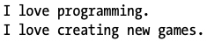

Appending to a File

If you want to add content to a file instead of writing over existing content, you can open the file in append mode. When you open a file in append mode, Python doesn’t erase the contents of the file before returning the file object. Any lines you write to the file will be added at the end of the file. If the file doesn’t exist yet, Python will create an empty file for you. Let’s modify write_message.py by adding some new reasons we love programming to the existing file programming.txt:

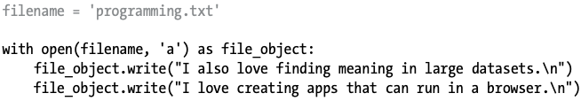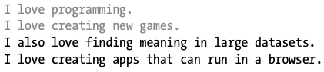

Exceptions

What is an Exception?

Python uses special objects called exceptions to manage errors that arise during a program’s execution. Whenever an error occurs that makes Python unsure what to do next, it creates an exception object. If you write code that handles the exception, the program will continue running. If you don’t handle the exception, the program will halt and show a traceback, which includes a report of the exception that was raised.

Exceptions are handled with try-except blocks. A try-except block asks Python to do something, but it also tells Python what to do if an exception is raised. When you use try-except blocks, your programs will continue running even if things start to go wrong. Instead of tracebacks, which can be confusing for users to read, users will see friendly error messages that you write.

- Special object created when an error occurs.
- Stops program unless handled.
- Displays a traceback if not handled.

try-except Block

Basic Structure
try:
# code that may cause error
except SomeError:
# what to do if error occurs

Handling ZeroDivisionError

We put print(5/0), the line that caused the error, inside a try block. If the code in a try block works, Python skips over the except block. If the code in the try block causes an error, Python looks for an except block whose error matches the one that was raised and runs the code in that block.
In this example, the code in the try block produces a ZeroDivisionError, so Python looks for an except block telling it how to respond. Python then runs the code in that block, and the user sees a friendly error message instead of a traceback:

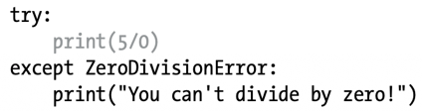

Handling Exceptions to Prevent Crashes
Handling errors correctly is especially important when the program has more work to do after the error occurs. This happens often in programs that prompt users for input. If the program responds to invalid input appropriately, it can prompt for more valid input instead of crashing.

Let’s create a simple calculator that does only division:

This program prompts the user to input a first_number and, if the user does not enter q to quit, a second_number. We then divide these two numbers to get an answer. This program does nothing to handle errors, so asking it to divide by zero causes it to crash:

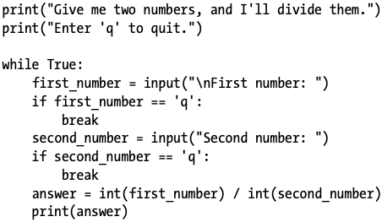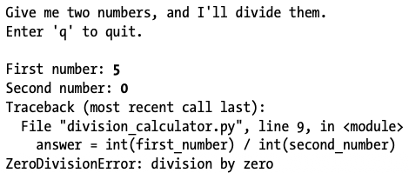

It’s bad that the program crashed, but it’s also not a good idea to let users see tracebacks. Nontechnical users will be confused by them, and in a malicious setting, attackers will learn more than you want them to know from a traceback. For example, they’ll know the name of your program file, and they’ll see a part of your code that isn’t working properly. A skilled attacker can sometimes use this information to determine which kind of attacks to use against your code.

The else Block
try-except-else Structure
try:
# risky code
except ErrorType:
# handle error
else:
# runs if no error
- try → risky code only
- except → handles specific error
- else → runs if try succeeds

We can make this program more error resistant by wrapping the line that might produce errors in a
try-except block. The error occurs on the line that performs the division, so that’s where we’ll put the
try-except block. This example also includes an else block. Any code that depends on the try
block executing successfully goes in the else block:

We ask Python to try to complete the division operation in a try block, which includes only the code that might cause an error. Any code that depends on the try block succeeding is added to the else block.
In this case if the division operation is successful, we use the else block to print the result.
The except block tells Python how to respond when a ZeroDivisionError arises. If the try block doesn’t succeed because of a division by zero error, we print a friendly message telling the user how to avoid this kind of error. The program continues to run, and the user never sees a traceback:

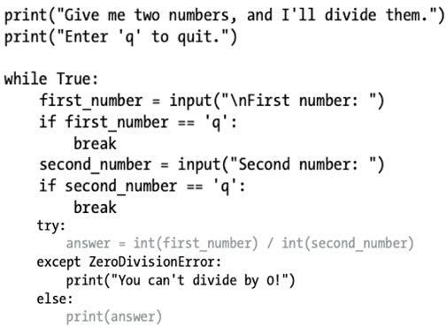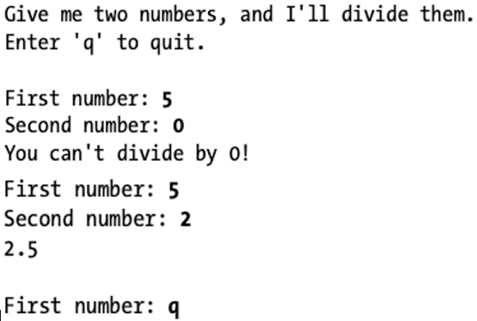

The try-except-else block works like this: Python attempts to run the code in the try block. The only code that should go in a try block is code that might cause an exception to be raised. Sometimes you’ll have additional code that should run only if the try block was successful; this code goes in the else block. The except block tells Python what to do in case a certain exception arises when it tries to run the code in the try block.
By anticipating likely sources of errors, you can write robust program that continue to run even when they encounter invalid data and missing resources. Your code will be resistant to innocent user mistakes and malicious attacks.

Preventing Program Crashes
- Use exceptions in:
  - User input
  - File handling
  - Network access
- Improves user experience.
- Avoids exposing technical tracebacks.

Handling FileNotFoundError
One common issue when working with files is handling missing files. The file you’re looking for might be in a different location, the filename may be misspelled, or the file may not exist at all. You can handle all of these situations in a straightforward way with a try-except block. Let’s try to read a file that doesn’t exist. The following program tries to read in the contents of Alice in Wonderland, but I haven’t saved the file alice.txt in the same directory as alice.py:

There are two changes here. One is the use of the variable f to represent the file object, which is a common convention. The second is the use of the encoding argument. This argument is needed when your system’s default encoding doesn’t match the encoding of the file that’s being read.

Python can’t read from a missing file, so it raises an exception:

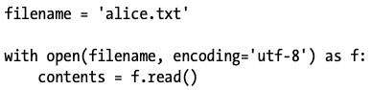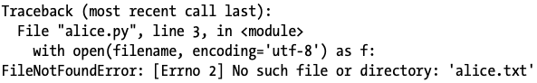

The last line of the traceback reports a FileNotFoundError: this is the exception Python creates when it can’t find the file it’s trying to open. In this example, the open() function produces the error, so to handle it, the try block will begin with the line that contains open()

In this example, the code in the try block produces a FileNotFoundError, so Python looks for an except block that matches that error. Python then runs the code in that block, and the result is a friendly error message instead of a traceback:

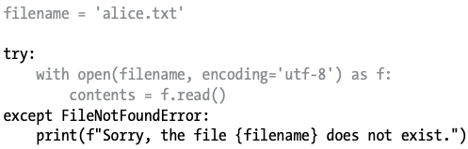

Analyzing Text

Counting Words
You can analyze text files containing entire books. Many classic works of literature are available as simple text files because they are in the public domain. The texts used in this section come from Project Gutenberg (http://gutenberg.org/). Project Gutenberg maintains a collection of literary works that are available in the public domain, and it’s a great resource if you’re interested in working with literary texts in your programming projects.
Let’s pull in the text of Alice in Wonderland and try to count the number of words in the text. We’ll use the string method split(), which can build a list of words from a string. Here’s what split() does with a string containing just the title "Alice in Wonderland":

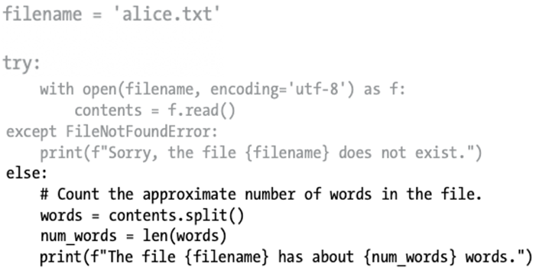

I moved the file alice.txt to the correct directory, so the try block will work this time. We take the string contents, which now contains the entire text of Alice in Wonderland as one long string, and use the split() method to produce a list of all the words in the book. When we use len() on this list to examine its length, we get a good approximation of the number of words in the original string. We print a statement that reports how many words were found in the file. This code is placed in the else block because it will work only if the code in the try block was executed successfully. The output tells us how many words are in alice.txt:

The count is a little high because extra information is provided by the publisher in the text file used here, but it’s a good approximation of the length of Alice in Wonderland.

Working with Multiple Files
Let’s add more books to analyze. But before we do, let’s move the bulk of this program to a function called count_words(). By doing so, it will be easier to run the analysis for multiple books:

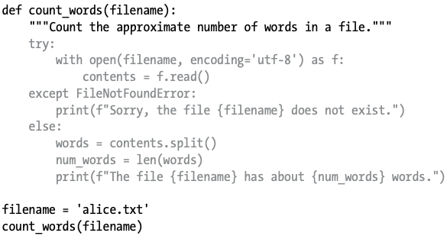

Most of this code is unchanged. We simply indented it and moved it into the body of count_words(). It’s a good habit to keep comments up to date when you’re modifying a program, so we changed the comment to a docstring and reworded it slightly.
Now we can write a simple loop to count the words in any text we want to analyze. We do this by storing the names of the files we want to analyze in a list, and then we call count_words() for each file in the list. We’ll try to count the words for Alice in Wonderland, Siddhartha, Moby Dick, and Little Women, which are all available in the public domain. I’ve intentionally left siddhartha.txt out of the directory containing word_count.py, so we can see how well our program handles a missing file:

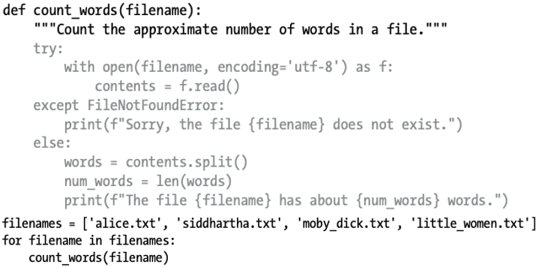

The missing siddhartha.txt file has no effect on the rest of the program’s execution:

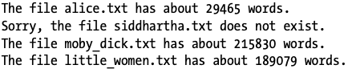

Using the try-except block in this example provides two significant advantages. We prevent our users from seeing a traceback, and we let the program continue analyzing the texts it’s able to find. If we don’t catch the FileNotFoundError that siddhartha.txt raised, the user would see a full traceback, and the program would stop running after trying to analyze Siddhartha. It would never analyze Moby Dick or Little Women.

Failing Silently
except FileNotFoundError:
pass
- Program continues.
- No error message shown.
- Useful when missing data is acceptable.

In the previous example, we informed our users that one of the files was unavailable. But you don’t need to report every exception you catch. Sometimes you’ll want the program to fail silently when an exception occurs and continue on as if nothing happened. To make a program fail silently, you write a try block as usual, but you explicitly tell Python to do nothing in the except block. Python has a pass statement that tells it to do nothing in a block:

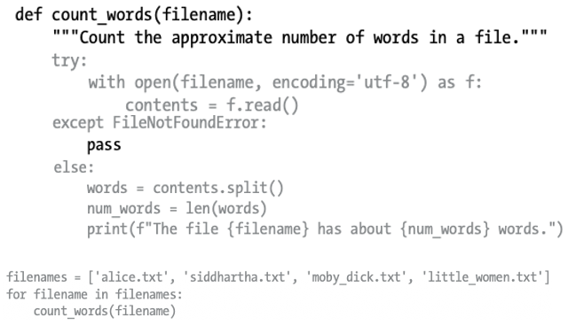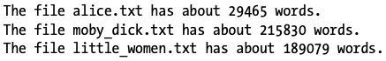

The only difference between this listing and the previous one is the pass statement. Now when a FileNotFoundError is raised, the code in the except block runs, but nothing happens. No traceback is produced, and there’s no output in response to the error that was raised. Users see the word counts for each file that exists, but they don’t see any indication that a file wasn’t found.

The pass statement also acts as a placeholder. It’s a reminder that you’re choosing to do nothing at a specific point in your program’s execution and that you might want to do something there later. For example, in this program we might decide to write any missing filenames to a file called missing_files.txt. Our users wouldn’t see this file, but we’d be able to read the file and deal with any missing texts.

Deciding When to Report Errors
- Report errors when:
  - User expects specific output.
- Fail silently when:
  - Missing data doesn’t affect user experience.
- Depends on usability and context.

How do you know when to report an error to your users and when to fail silently? If users know which texts are supposed to be analyzed, they might appreciate a message informing them why some texts were not analyzed. If users expect to see some results but don’t know which books are supposed to be analyzed, they might not need to know that some texts were unavailable. Giving users information they aren’t looking for can decrease the usability of your program. Python’s error-handling structures give you fine-grained control over how much to share with users when things go wrong; it’s up to you to decide how much information to share.
Well-written, properly tested code is not very prone to internal errors, such as syntax or logical errors. But every time your program depends on something external, such as user input, the existence of a file, or the availability of a network connection, there is a possibility of an exception being raised. A little experience will help you know where to include exception handling blocks in your program and how much to report to users about errors that arise.

What is the difference between opening a file with and without json

Without json
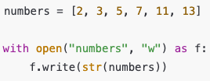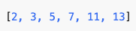

- Write() only works with strings, not lists
- Writes to the file numbers (as a string)

When you read it back:

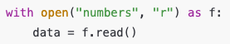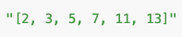

- It is not a python list anymore (it is a string)
- To work with it, you will need to manually convert it back to a list, which could lead to errors.

With json

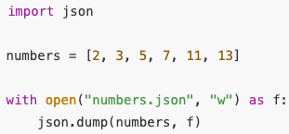

- json.dump() converts the list into JSON format (looks like a Python list)
- Saves it safely to a file

When you read it back:

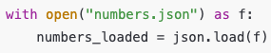

- numbers_loaded is now a Python list again [2,3,5,7,11,13]
- No dangerous conversions of strings

Key Differences
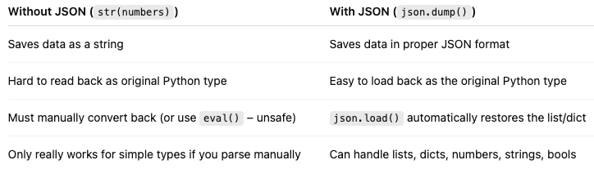

Storing Data with JSON

What is JSON?
- JavaScript Object Notation.
- Portable data format.
- Works across programming languages.

The json module allows you to dump simple Python data structures into a file and load the data from that file the next time the program runs. You can also use json to share data between different Python programs. Even better, the JSON data format is not specific to Python, so you can share data you store in the JSON format with people who work in many other programming languages. It’s a useful and portable format, and it’s easy to learn.

Using json.dump() : “Take my python data and write it into a file”
Let’s write a short program that stores a set of numbers and another program that reads these numbers back into memory. The first program will use json.dump() to store the set of numbers, and the second program will use json.load().
The json.dump() function takes two arguments: a piece of data to store and a file object it can use to store the data. Here’s how you can use json.dump() to store a list of numbers:

number_writer.py

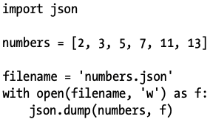

- First import json
- Create a list with given data
- Create a variable (filename) for file (number.json)
NOTE: numbers is not the file (it’s a list of data). numbers.json is the file
- - Open the file numbers.json
- We opened the file in write mode “w”,
which allows json to write the data to the file with the file object f
NOTE:
“w” either writes to an existing file and erases all data and input the new data
OR “w” creates a new file and writes the data into that
- json.dump() puts the list numbers into the file numbers.json
- now it is saved into the computer (even if the program closes, the file still exists)

This program has no output, but let’s open the file numbers.json and look at it. The data is stored in a format that looks just like Python:

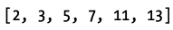

Quick Reminder:

with open(filename, “w”) as f:
- f is a file object.
- A file object is Python’s handle to the file, not the file itself.
- You use f to read from or write to the file.

Think of it like a remote control to the file:
- The file = the physical data on disk (numbers.json)
- The file object f = your way to access that data in Python

Using json.load()
Now we’ll write a program that uses json.load() to read the list back into memory:

number_reader.py

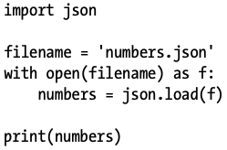

- First import json
- Open the file and make sure to read from the same file we wrote to.
Open the file in read mode because Python only needs to read from the file.
- json.load() function to load the information stored in numbers.json
and then assign it to the variable numbers.
- Finally we can print the data numbers

This is a simple way to share data between two programs.

Saving and Reading User-Generated Data

Saving data with json is useful when you’re working with user-generated data, because if you don’t store your user’s information somehow, you’ll lose it when the program stops running. Let’s look at an example where we prompt the user for their name the first time they run a program and then remember their name when they run the program again.

Let’s start by storing the user’s name:

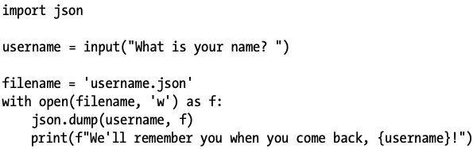

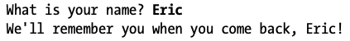
- Prompt for a username to be stored
- Use json.dump(), passing the username and file object to store the username into the file
- Print a message informing the user that we have stored their file information

Now let’s write a new program that greets a user whose name has already been stored:

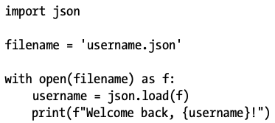

Combined Version with Exception Handling

We need to combine these two programs into one file. When someone runs remember_me.py, we want to retrieve their username from memory if possible; therefore, we’ll start with a try block that attempts to recover the username. If the file username.json doesn’t exist, we’ll have the except block prompt for a username and store it in username.json for next time:

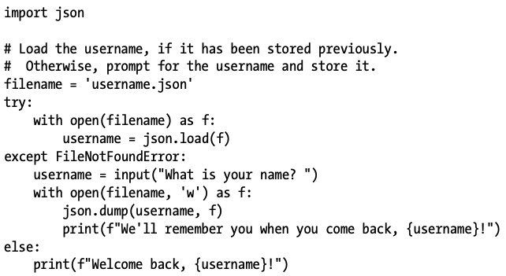

There’s no new code here; blocks of code from the last two examples are just combined into one file. We try to open the file username.json. If this file exists, we read the username back into memory and print a message welcoming back the user in the else block. If this is the first time the user runs the program, username.json won’t exist and a FileNotFoundError will occur. Python will move on to the except block where we prompt the user to enter their username. We then use json.dump() to store the username and print a greeting.
Whichever block executes, the result is a username and an appropriate greeting. If this is the first time the program runs, this is the output:

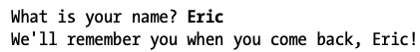

Otherwise:
This is the output you see if the program was already run at least once.

try:
with open(filename) as f:
username = json.load(f)
except FileNotFoundError:
username = input("What is your name? ")
with open(filename, 'w') as f:
json.dump(username, f)
else:
print(f"Welcome back, {username}!")

Refactoring

What is Refactoring?

Often, you’ll come to a point where your code will work, but you’ll recognize that you could improve the code by breaking it up into a series of functions that have specific jobs. This process is called refactoring. Refactoring makes your code cleaner, easier to understand, and easier to extend.
We can refactor remember_me.py by moving the bulk of its logic into one or more functions. The focus of remember_me.py is on greeting the user, so let’s move all of our existing code into a function called greet_user():

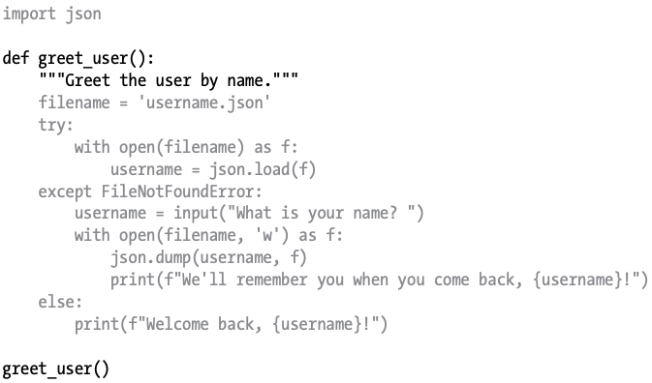

Because we’re using a function now, we update the comments with a docstring that reflects how the program currently works u. This file is a little cleaner, but the function greet_user() is doing more than just greeting the user—it’s also retrieving a stored username if one exists and prompting for a new username if one doesn’t exist.

Let’s refactor greet_user() so it’s not doing so many different tasks. We’ll start by moving the code for retrieving a stored username to a separate function:

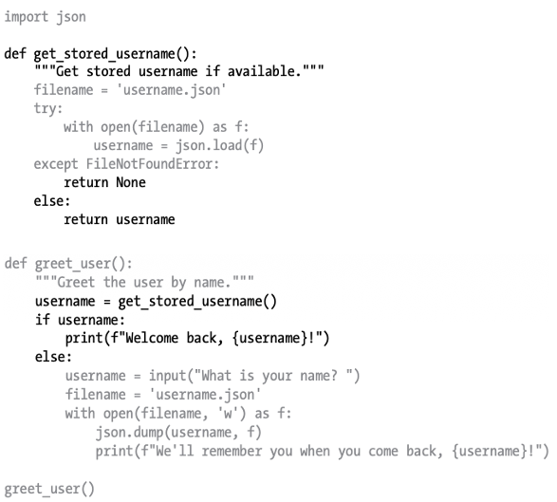

The new function get_stored_username() has a clear purpose, as stated in the docstring. This function retrieves a stored username and returns the username if it finds one. If the file username.json doesn’t exist, the function returns None. This is good practice: a function should either return the value you’re expecting, or it should return None. This allows us to perform a simple test with the return value of the function. We print a message welcome back message to the user if the attempt to retrieve a username was successful, and if it doesn’t, we prompt for a new username.

We should factor one more block of code out of greet_user(). If the username doesn’t exist, we should move the code that prompts for a new username to a function dedicated to that purpose:

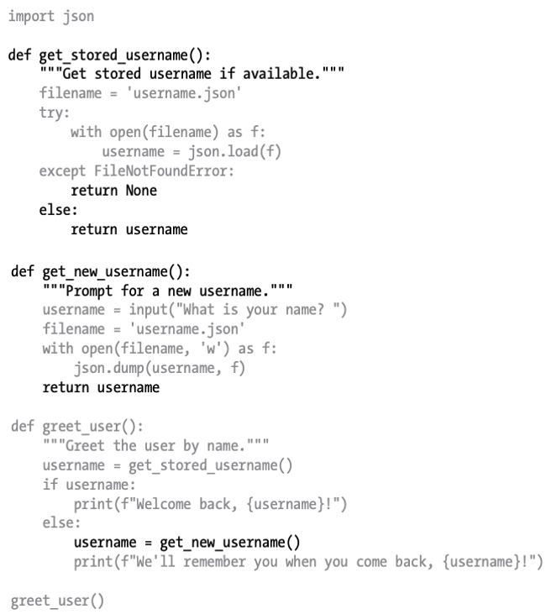

Each function in this final version of remember_me.py has a single, clear purpose. We call greet_user(), and that function prints an appropriate message: it either welcomes back an existing user or greets a new user. It does this by calling get_stored_username(), which is responsible only for retrieving a stored username if one exists. Finally, greet_user() calls get_new_username() if necessary, which is responsible only for getting a new username and storing it. This compartmentalization of work is an essential part of writing clear code that will be easy to maintain and extend.

Breaking into Functions

Example Structure
def get_stored_username():
...

def get_new_username():
...

def greet_user():
...

Benefits
- Each function has one clear purpose.
- Easier to debug.
- More readable.

Key Takeaways
- Use with open() to safely work with files.
- Use .read(), loop, or .readlines() to access data.
- Use write modes carefully.
- Always anticipate errors.
- Use try-except-else for robust programs.
- Use json to store and retrieve persistent data.
- Refactor code into focused functions.
- Good error handling improves user experience and security.

